**OOP Lab #1**

**Difference between Class and Object**

**Class:**

* Class is a blueprint/template.
* Class is not a real world entity.
* Classes do not occupy memory in system.
* Class has Attributes and Behavior.

Object:

* Object is instance of class.
* Object is a real world entity.
* Object occupies memory.
* Based on class object has same Attributes and Behavior.

Example of code:

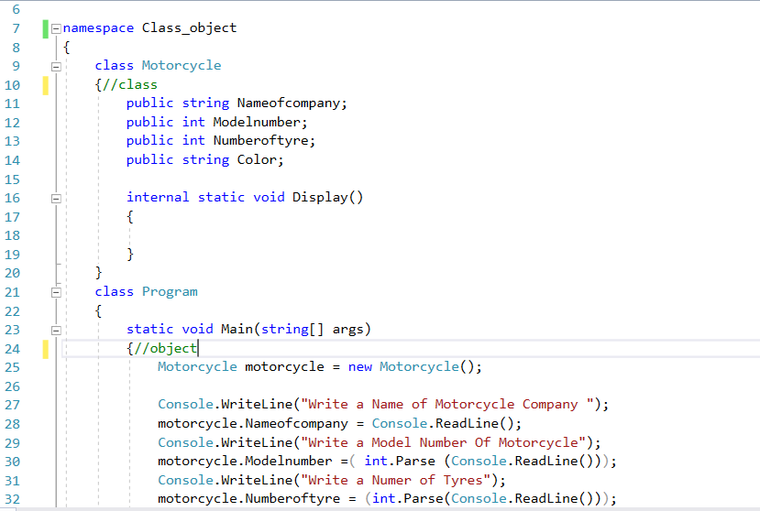

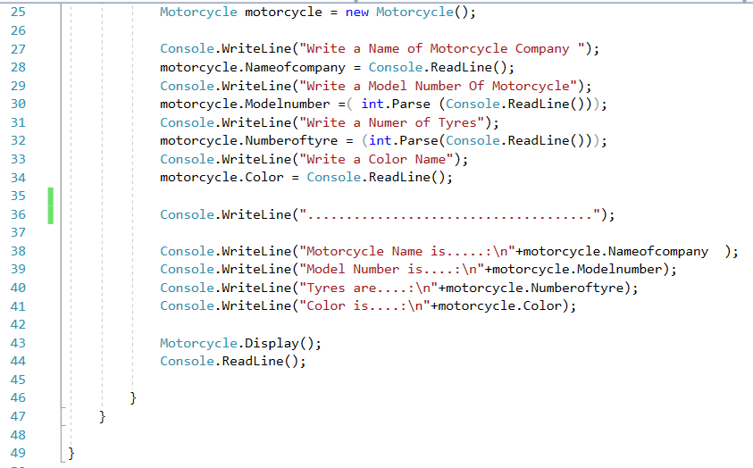

The output will be….

